Member Profile -> Master data -> Payment Details
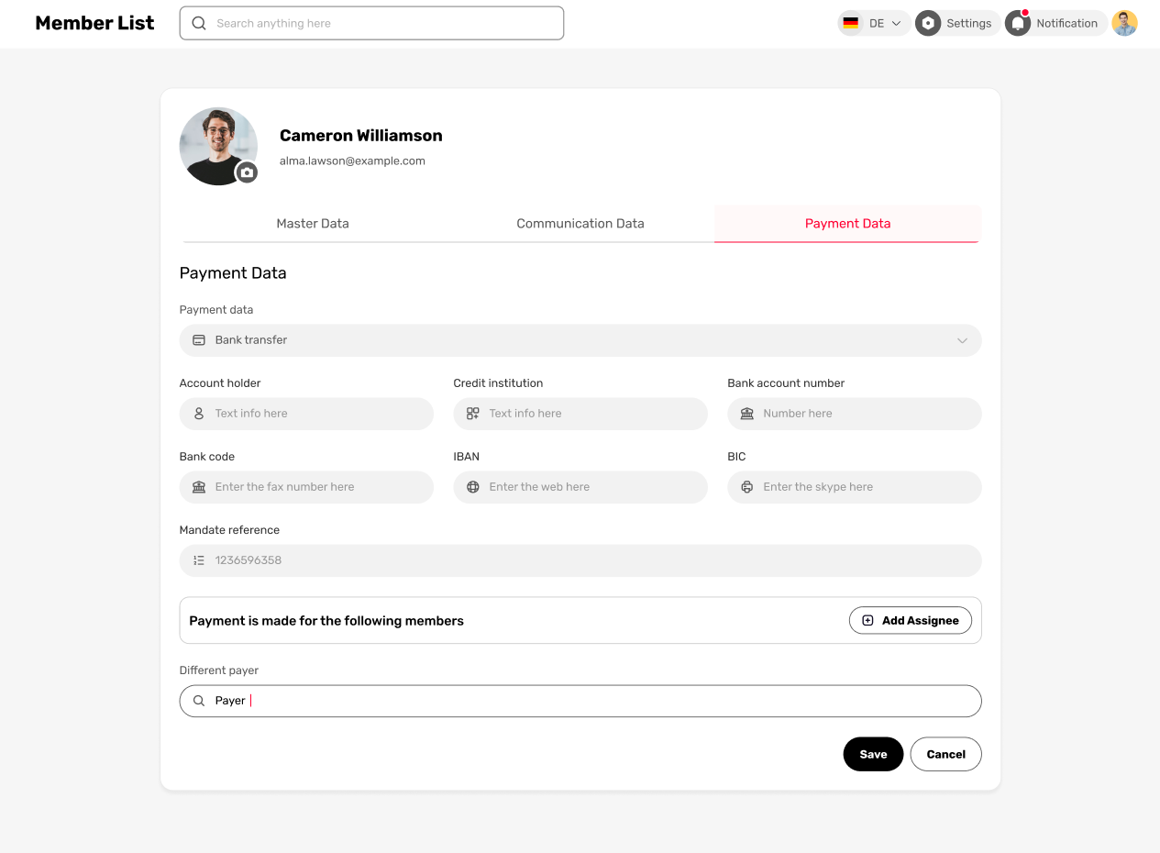
2
1
All mandatory fields are marked with *
- Payment data
14.10.2025 Please note: It should be possible to add multiple payment data for bank transfer and direct debit. For example, the payment method can flexibly be chosen when assigning a contribution.
Dropdown:
- None
- Cash
- Bank transfer
  - Account holder [text]
  - Credit institution [text]
  - Bank account number [number]
  - Bank code [number]
  - IBAN
  - BIC
  - Mandate reference [number]
- Direct debit
  - Same fields like “bank transfer”. Only difference: IBAN is mandatory
  - Note: If the IBAN starts with “CH”, these additional fields appear:
    - Street*
    - City*
    - Postal Code*

If “Direct Debit” is selected, these additional fields are displayed below “Mandate reference”:
- Button 1: “Add direct debit mandate”.
If Button is clicked, a popup appears with these fields:
  - DD-Mandate exists [selection]
    - Yes
    - No
      - If No: Upload DD-Mandate* [PDF, PNG, JPG]
  - Signature date* [date]
  - Type [selection]
    - Unique
    - Recurring [default]
  - Notification [date]
- Button 2: “Generate DD-Form”
  - PDF will be generated
  - See document attached (template)
- Info-Text beneath the Buttons: “If no direct debit mandate exists, it is not possible to collect payments (e.g. contributions) from the member.”
If at least one DD-Mandate exists, a list will appear beneath the two Buttons:
Mandate Management [List]
- Note: This list contains all added direct debit mandates (DDM). The list is only visible, if at least one Direct debit mandate was created. A member can have multiple DDMs. He can generate, add, view, edit, and delete them.
  - Generate: Creates a PDF file based on the data typed under Payment option “Direct debit”.
  - Add: See below under “Add direct debit mandate”
  - View: The generated DDM (PDF) is opened.
  - Edit: The DDMs values can be updated (see below under “Add direct debit mandate”)
  - Delete: The DDMs can be deleted from the lists, which needs to be confirmed (“are you sure you want to delete…”)
- Columns
  - Direct Debit [File name]
  - Signature Date [date]
  - Validity Date [date]
  - Property [text]
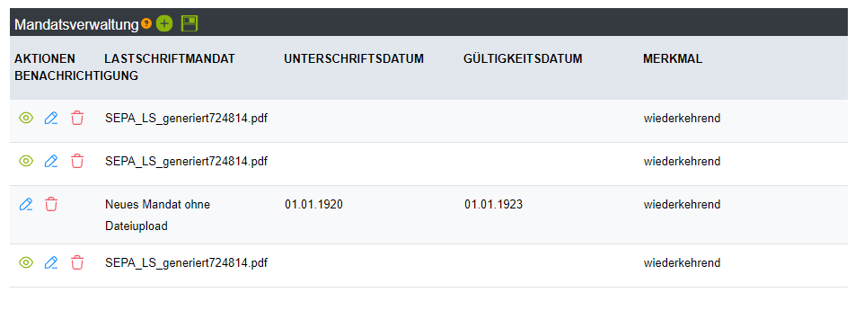
- Assign Payment
Group payment
Note: The club can add an unlimited number of members here who can be assigned to this member’s payment. For example, this function can be used when a member pays on behalf of their two daughters.
- Sub-Title: Payment is made for the following members
- Button: “Add member”
  - Popup
  - Title: Search member
  - Fields
    - Search-field
      - Autocomplete search: The user types “Müller” or “Anna”, for example, and suitable results appear immediately.
    - Show Results in a table
      - Results contain useful additional information for differentiation. Columns: Member number, date of birth, First name, Last name, Location
    - Button: “Add members”
      - Can select multiple search results and add them
  - After adding the member(s), they appear below “Payment is made for following members” in a table with these columns: Member number, date of birth, First name, Last name, Location
    - If no member is assigned, show text instead: “No member assigned”

Different payer
Note: The club can assign a different payer to this member’s fees. For example, a parent can be set as the payer for their two daughters’ memberships using this feature.
Important: If a member (e.g. daughter) is assigned under “Group payment” above (Nr. 2) to a member (e.g. father), in the daughter’s member profile, the father will automatically be listed under “Different payer”. And also vice versa: If the father is added as different payer for the daughter, in his profile, his daughter will appear under “Group payment”.
- Sub-Title: Payment is made by a different member
- Button: “Assign member”
  - Popup with same settings as stated above (“Add member”). Only difference:
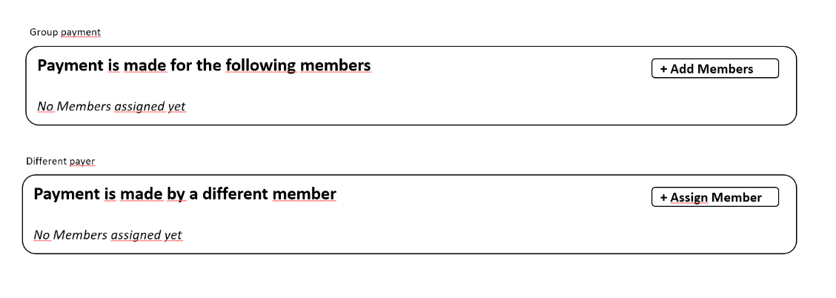
    - You can NOT add multiple members – just one member.

